Designing and Developing a Binary Adder
Godfrey Ouma
University of the People
CS 1105-01: Digital Electronics & Computer Architecture
Afrah Nazir
July 18, 2024

Designing and Developing a Binary Adder
a) Binary Adder
Binary Adders circuits can be used to “add” together two binary numbers producing a “carry-out”. In its most basic form, adders can be made from connecting together an Exclusive-OR gate with an AND gate to produce a Half Adder circuit. Two half adders can then be combined to produce a Full Adder. A full adder circuit is an arithmetic circuit block that can be used to add three bits to produce a SUM and a CARRY output. Such a building block becomes a necessity when it comes to adding binary numbers with a large number of bits. The full adder circuit overcomes the limitation of the half-adder, which can be used to add two bits only.
Full Adder Block Diagram
Outputs
Inputss
SUM
A
Full Adder
B
S
C_{out}
CARRY OUT
C_{in}

Truth Table
C-in | B | A | Sum | C-out
0 | 0 | 0 | 0 | 0
0 | 0 | 1 | 1 | 0
0 | 1 | 0 | 1 | 0
0 | 1 | 1 | 0 | 1
1 | 0 | 0 | 1 | 0
1 | 0 | 1 | 0 | 1
1 | 1 | 0 | 0 | 1
1 | 1 | 1 | 1 | 1

Circuit Diagram
Then the Boolean expression for a full subtractor is as follows.
For the SUM (S) bit:
SUM = (A XOR B) XOR Cin = (A ⊕ B) ⊕ Cin
For the CARRY-OUT (Cout) bit:
CARRY-OUT = A AND B OR Cin(A XOR B) = A.B + Cin(A ⊕ B)
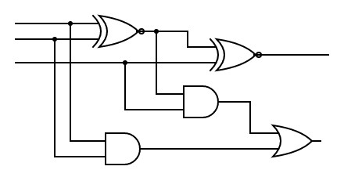
C_{in}
B
A
C_{out}
SUM
- Binary Subtractor
The Binary Subtractor is a type of combinational arithmetic circuit that produces an output which is the subtraction of two binary numbers. As their name implies, a Binary Subtractor is a decision -making circuit that subtracts two binary numbers from each other, for example, X – Y to find the resulting difference between the two numbers. Unlike the Binary Adder which produces a SUM and a CARRY bit when two binary numbers are added together, the binary subtractor produces a DIFFERENCE, D by using a BORROW bit, B from the previous column.
Full Binary Subtractor Block Diagram
Inputs
Outputs
DIFFERENCE
X
D
Full Subtractor
BORROW OUT
Y
B_{out}
B_{in}

Truth Table
B-in | Y | X | Diff | B-out
0 | 0 | 0 | 0 | 0
0 | 0 | 1 | 1 | 0
0 | 1 | 0 | 1 | 1
0 | 1 | 1 | 0 | 0
1 | 0 | 0 | 1 | 1
1 | 0 | 1 | 0 | 0
1 | 1 | 0 | 0 | 1
1 | 1 | 1 | 1 | 1

Circuit Diagram
Then the Boolean expression for a full subtractor is as follows.
For the DIFFERENCE (D) bit:
D = (X.Y.B_{IN}) + (X.Y.B_{IN}) + (X.Y.B_{IN}) + (X.Y.B_{IN})
which can be simplified too:
D = (X XOR Y) XOR B_{IN} = (X ⊕ Y) ⊕ B_{IN}
For the BORROW OUT (B_{OUT}) bit:
B_{OUT} = (X.Y.B_{IN}) + (X.Y.B_{IN}) + (X.Y.B_{IN}) + (X.Y.B_{IN})
which will also simplify too:
B_{OUT} = X AND Y OR (X XOR Y)B_{IN} = X.Y + $\overline{(X ⊕ Y)}B_{IN}$
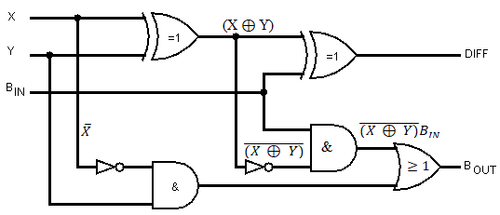
- Multiplier
A binary multiplier is a combinational logic circuit used in digital systems to perform the multiplication of two binary numbers. These are most commonly used in various applications especially in the field of digital signal processing to perform the various algorithms. Compared with addition and subtraction, multiplication is a complex process. In multiplication process, the number which is to be multiplied by the other number is called as multiplicand and the number multiplied is called as multiplier. This multiplication is implemented by combinational circuit such that the multiplication is performed with AND gates whereas the addition is carried out by using half adders.
Circuit Diagram
Schematic of 2-bit by 2-bit binary multiplier implement with two XOR gates and six AND gates
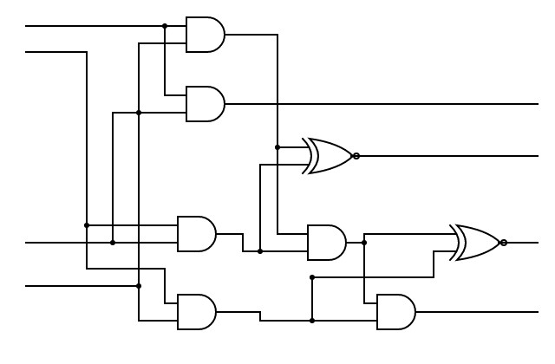
C2
C3
C1
C0
B1
B0
A1
A0
- Binary Divider
The binary division calculator simply explains how to divide two binary numbers and provides a step-by-step procedure to perform the division of the binary number. The circuit diagram of binary division signifies a 2-bit divider circuit. The two bits input for one number are X0, X1, and Y0, and Y1 is for another number. In the circuit, the Z0, Z1, Z2 & Z3 signify the representation of binary form for the quotient. The circuit is designed with logic gates like AND & Ex-OR gates which are shown in the above figure. The most popular logic gate operation can be found in different circuits like multiplexer (Mux) & demultiplexer (Demux).
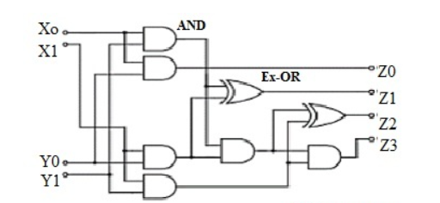
Integrating and Organizing Modules
Integrating these modules to perform seamless mathematical operations involves creating a structured architecture combining adder, subtractor, multiplier, and divider modules. The design can be organized around a central controller that manages the flow of operations, activating the appropriate module based on the user’s input. Each operation's inputs are parsed, and the selected module computes the result, which is then displayed to the user. This structure ensures modularity and simplifies debugging and maintenance.
Examples of Binary Calculations
Binary Addition: Adding binary numbers 1010 and 0110 involves performing bitwise addition starting from the least significant bit:
- 0 + 0 = 0 (Sum), Carry = 0
- 1 + 1 = 0 (Sum), Carry = 1 (next column)
- 0 + 1 + 1 (Carry) = 0 (Sum), Carry = 1
- 1 + 0 + 1 (Carry) = 0 (Sum), Carry = 1
The final result is 10000.
Binary Subtraction: Subtracting 0110 from 1010:
- 0 - 0 = 0
- 1 - 1 = 0
- 0 - 1 = 1 (borrow 1)
- 1 - 1 (with borrow) = 0
The result is 0100.
Binary Multiplication: Multiplying 1010 by 0110 involves generating partial products and summing them:
- Partial products: 1010, 0000, 10100, 00000
- Sum: 111100
Binary Division: Dividing 1010 by 0010:
- Perform binary division similar to long division.
- Quotient: 0101, Remainder: 0
Advantages and Challenges of Binary Arithmetic
Binary arithmetic offers several advantages. It is simpler to implement in digital circuits, as binary digits (bits) are easier to manage electronically. Operations are faster due to the straightforward nature of binary addition, subtraction, multiplication, and division. Additionally, error detection and correction are more efficient in binary systems. However, binary arithmetic can be less intuitive for humans, and binary numbers are often longer than their decimal counterparts, which can complicate reading and interpretation. Precision can also be an issue due to fixed bit lengths in digital representations.
Significance of Designing a Binary Calculator
Designing a binary calculator is a significant educational exercise that promotes a deeper understanding of number systems and mathematical operations. It bridges theoretical concepts with practical applications, enhancing comprehension of how digital systems perform arithmetic. This project helps in understanding binary logic, circuit design, and the fundamental operations of computer systems. By working through the design and implementation of a binary calculator, one gains valuable insights into digital electronics, fostering skills that are crucial in fields like computer engineering and digital signal processing.

References
Agarwal, T. (2022, July 13). Binary Division : Algorithm, Examples, Calculator and Its Circuit. ElProCus - Electronic Projects for Engineering Students. https://www.elprocus.com/binary-division/
Binary Adder and Binary Addition using Ex-OR Gates. (2013, August). Basic Electronics Tutorials. https://www.electronics-tutorials.ws/combination/comb_7.html
Binary Subtractor used for Binary Subtraction. (2015, April 14). Basic Electronics Tutorials. https://www.electronics-tutorials.ws/combination/binary-subtractor.html
DEPARTMENT OF ELECTRONICS AND COMMUNICATION ENGINEERING ACTIVITY BASED LEARNING Course Code & Course Title : 19EC303 -Digital Principles and System Design. (n.d.). https://www.saveetha.ac.in/images/sec/2021/ECE/ITM/Binary_Multiplier.pdf

